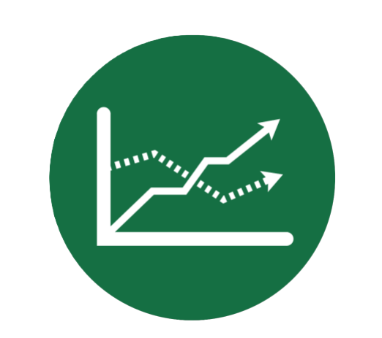
Portfolio Comparison
User Guide
Contents
Portfolio Insight 3
Funds and MPS Research 4
Fund Filters 4
Universe & Availability 4
Ratings 4
Sectors 4
Costs & Fees 5
Asset Content 5
Fund Attributes 5
Performance Metrics 5
Fund Characteristics 5
Performance Quartiles 6
View 6
Audit Report 6
Actions 7
Active Filters 7
Starred Funds 7
Actions 7
Performance 10
Risk 10
Asset Allocation 12
Portfolio Holdings 13
Product Availability 13
Projected Values 14
Glossary of Filters 15
Universe and Availability 15
Fund Universe 15
Legal Structure 15
Plan Availability 15
Ratings 15
Minimum Morningstar Rating 15
Sectors 15
Costs & Fees 15
Total Cost 15
Costs Excluding Transaction Fees 15
Asset Content 15
Equity Content 15
Fixed Interest Content 15
Regional Equity Content 15
Fund Attributes 16
Performance Metrics 16
Performance Quartiles 16
Cumulative Performance 16
Alpha Ratio 16
Beta Ratio 16
Sharpe Ratio 16
R² 16
Standard Deviation 16
Fund Characteristics 16
Min Fund Size 16
Fund Strategy 16
Fund of Funds 16
Fund Style – Size 16
Fund Style – Approach 17
Fund Type 17

Portfolio Insight
Portfolio Insight can be accessed directly from the Main Menu screen and does not need to be client specific.
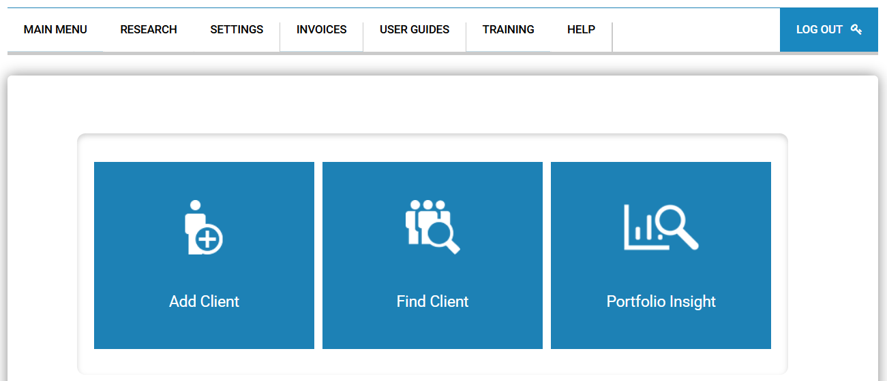
Alternatively, the tools can be accessed within a client, by clicking View Stored Analysis, or by clicking Funds & MPS Research within the Research tab at the top of the page.
Within the tool, there are the options for Funds and MPS Research, and Compare Portfolios. Funds and MPS Research will allow the user to search for and filter funds by set criteria and add these to portfolios. Previously created portfolios will show under Compare Portfolios.
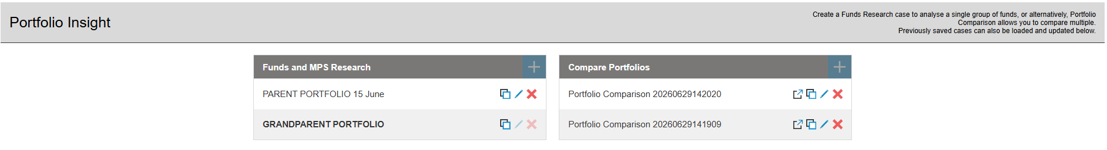
Use the clone icon to duplicate a portfolio, the pencil icon to edit the portfolio, and the red X icon to delete the portfolio.
The copy to client button on Compare Portfolios can be used to copy the portfolio to a specific client.

Funds and MPS Research
On the left-hand side of the screen, there is the option to search for a fund, using the fund name or ISIN. Alternatively, funds can be narrowed down by expanding and choosing from the list of filters below.
Alongside this, there is a tab for Templates, which will allow saved fund templates to be used in the analysis.
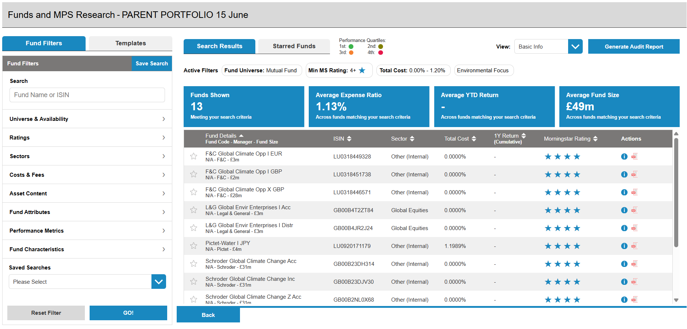

Fund Filters

Universe & Availability
Fund Universe – select whether the search results should be MPS, Pension Funds or Mutual Funds
Legal Structure – select to choose from ETFs, Investment Trusts, OEICs & Unit Trusts, or Offshore Funds
Plan Availability – choose from the list of products that these funds should be available with

Ratings
Minimum Morningstar Rating – use the slider to indicate the minimum acceptable Morningstar rating
Morningstar Medalist Rating – select which ratings to include

Sectors
Investment Sectors – choose the sectors to include from the drop-down list

Costs & Fees
Total Cost – use the sliders to indicate a minimum and maximum cost of the fund
Costs Excluding Transaction Fees – use the sliders to indicate a minimum and maximum cost of the fund, excluding transaction fees

Asset Content
Asset Content – use the sliders to indicate a minimum and maximum content of equities and fixed interest
Regional Equity Content – use the sliders to indicate a minimum and maximum content from each region

Fund Attributes
Use the tick boxes to refine funds including this selection of attributes

Performance Metrics
Use the sliders to select the term of investment to refine by and enter the required cumulative performance.
Use the minimum and maximum fields below to refine by alpha ratio, beta ratio, sharpe ratio and standard deviation.

Fund Characteristics
Minimum Fund Size – use the slider to indicate a minimum fund size
Fund Strategy – choose from the options in the drop-down list
Fund of Funds – choose from the options in the drop-down list
Fund Style – Size - choose from the options in the drop-down list
Fund Style – Approach - choose from the options in the drop-down list
Fund Type – select whether to include accumulation, income or mixed funds
At the bottom of this list, there is a drop-down of saved searches. Within here, there is a list of previously saved search criteria that can be loaded up to use again. Once the filters have been selected, an option to save search will appear at the top, next to the Fund Filters header.

Search results will show on the right-hand side of the screen and the active filters used for the search will be displayed at the top of the screen. To remove these filters, use the red X icon, which will automatically update the search results. Funds can be chosen by selecting the star icon on the left. These funds will appear under the tab “starred funds”.
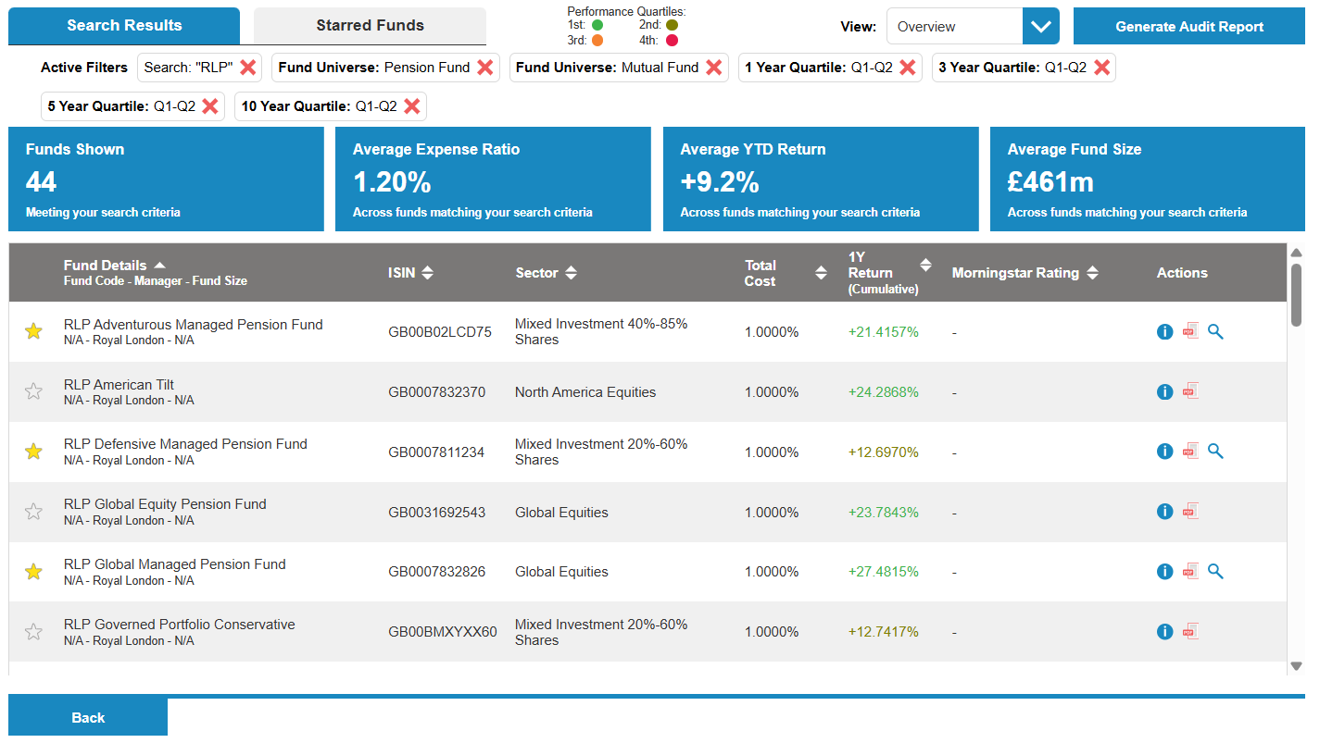

Performance Quartiles
Performance will be coloured to indicate the performance quartile of each fund.

View
The default list view will show the basic information, but this can be changed in the drop-down list to show cumulative performance, discrete performance and risk. The list can be sorted by each of the headers, using the relevant arrows.

Audit Report
To generate an audit report, use the button in the top right corner. This list will show all searches run in this session.
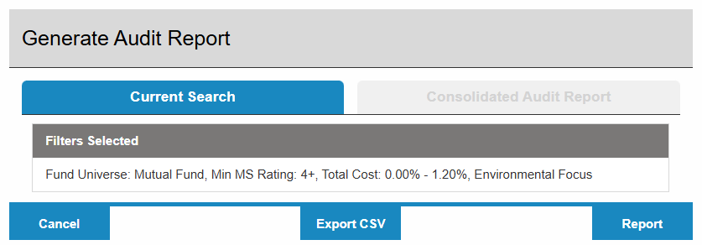

Actions
The information icon will display data for the individual fund, including the cost, performance, holdings and risk. Under fund links, there is the option to choose from other share classes of this fund.
The PDF icon will load a factsheet for the individual fund.

Active Filters
The active filters are shown at the top of the page. Use the red X to remove a filter. The search results will update automatically.

Starred Funds
Switch to the Starred Funds tab to compare and view the details of the selected funds.
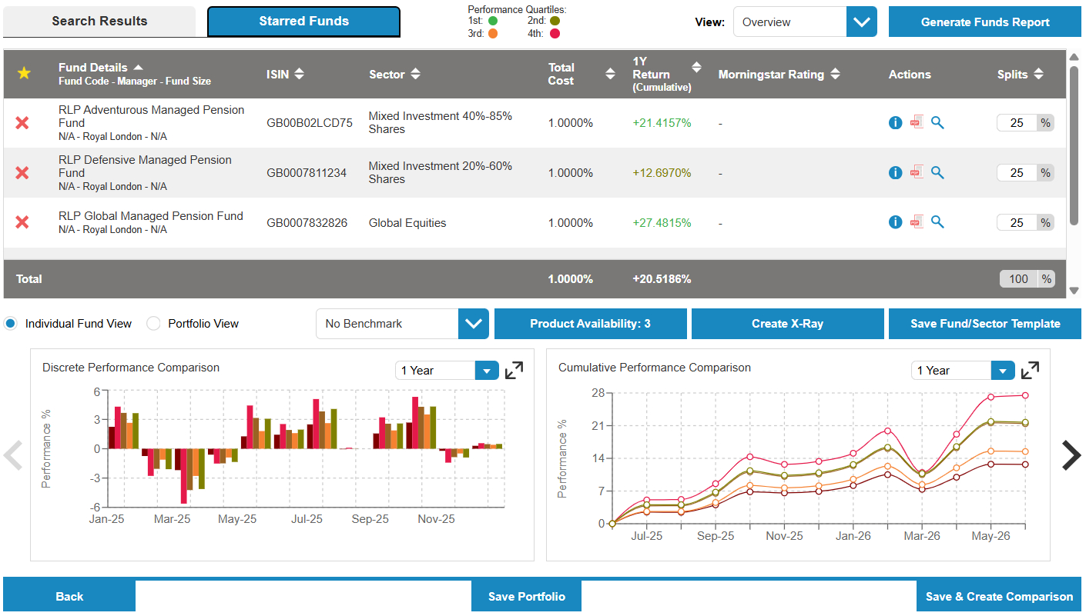
To generate a report on the funds listed, click the Generate Funds Report button.
Fund information can be reviewed without allocating a split to each fund. However, to be able to view overall portfolio data or save as a template, the splits must be specified. Once a split has been allocated and totals 100%, there will be the options to review the below information for the portfolio, in addition to the individual funds.

Actions
The information icon will display data for the individual fund, including the cost, performance, holdings and risk. Under fund links, there is the option to choose from other share classes of this fund.
The PDF icon will load a factsheet for the individual fund.
The search icon will load which filters were active at the time of favouriting this fund.
The graphs below can be viewed for the individual funds, or for the overall portfolio, using the radio buttons.
Benchmarks can be added to the graphs using the relative drop-down.
Click the Product Availability button to view a list of the products that are available with the fund selection, as well as the unavailable products together with the reason why this product is unavailable.
Use the arrows to scroll through the graphs. The term for each graph can be defined using the drop-down list on each of the graphs.
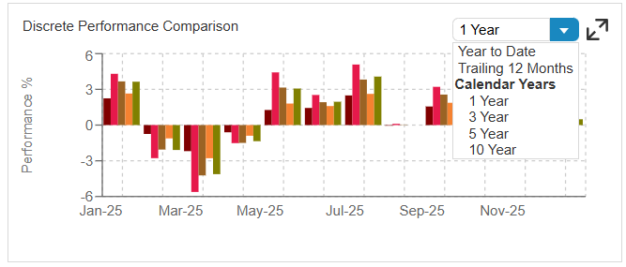

Further details can also be found on each graph by using the arrows in the top right corner to expand the graph.
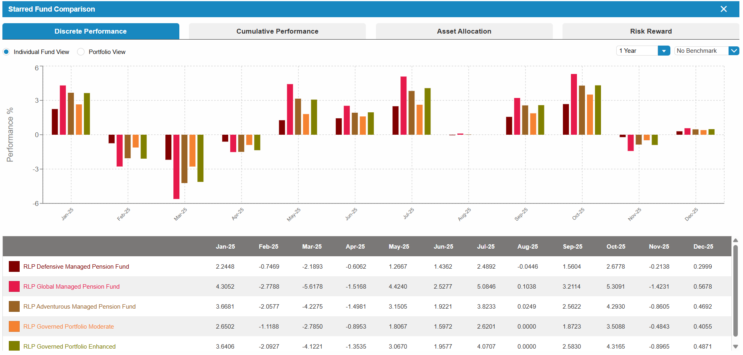

Once all of the funds have been added to the portfolio, click Save & Create Comparison.
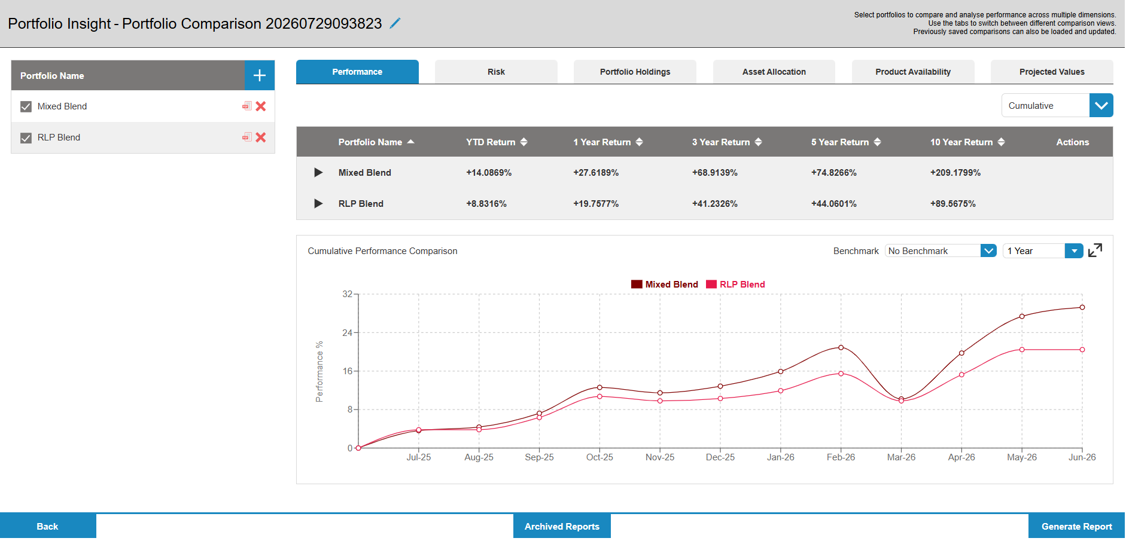
The saved portfolios will show in the list on the left-hand side. Tick the portfolios that are required for this comparison. The PDF icon will show an x-ray of each portfolio. Use the red X to delete a portfolio.
The overall information will be shown for each portfolio. To view the information for the individual funds within the portfolio, click the black triangle to expand the fund list.
Use the tabs across the top to show a comparison of Performance, Risk, Asset Allocation, Portfolio Holdings, Product Availability and Projected Values of each portfolio.
To add a benchmark or change the term of the analysis, use the drop-down options above the graphs.

Performance
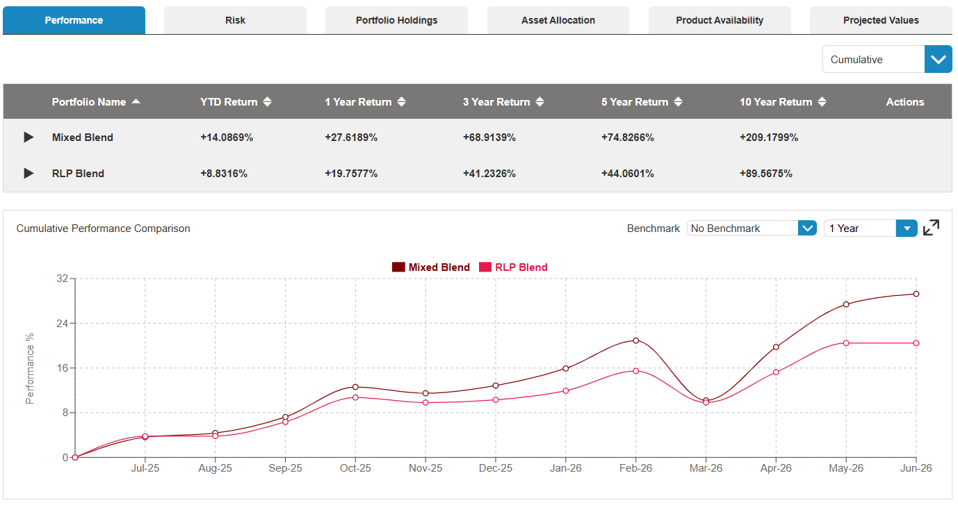
Use the drop-down on the top right to switch between cumulative and discrete performance.
The overall performance of the portfolio is shown as a default, but the underlying fund performance can be viewed by clicking on the black triangle icon.
A benchmark can be added from the drop-down list.
The term of the review can be chosen from the options above the graph.

Risk
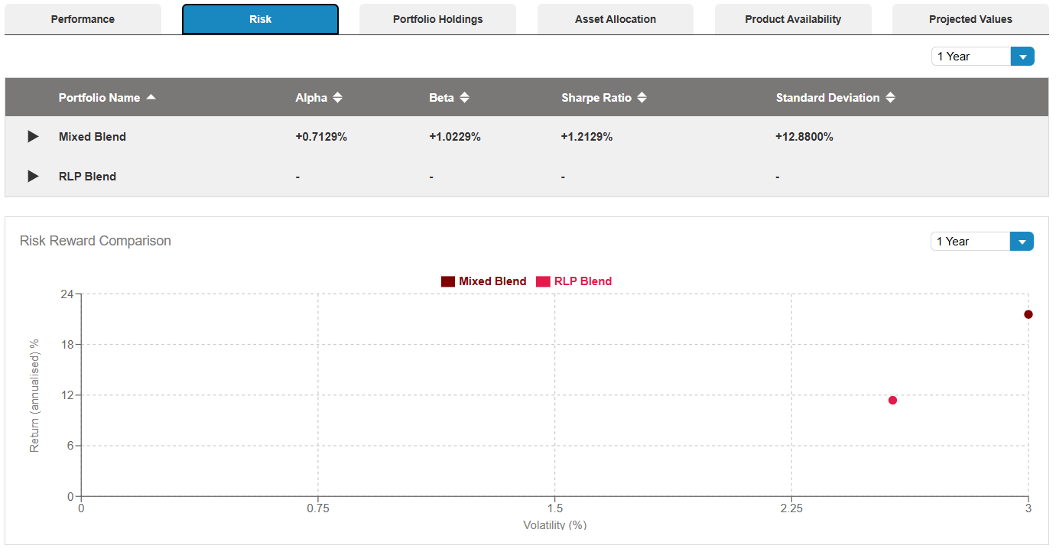
The Alpha, Beta and Sharpe Ratios, and Standard Deviation are displayed for the overall portfolio. To view this information for the underlying funds, use the black triangle to expand the fund list.
Use the drop-down list to choose the term of the comparison.

Asset Allocation
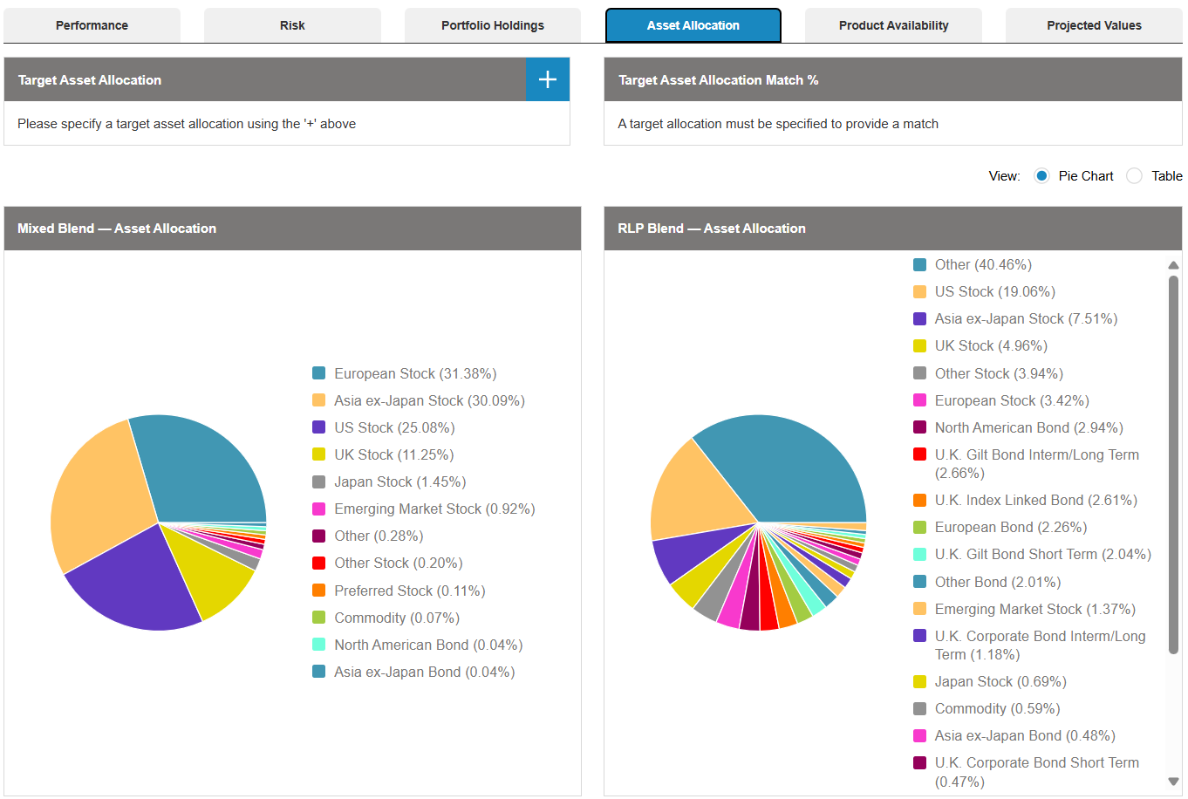
A target asset allocation can be added using the blue + icon. This will create a comparison between the target asset allocation and the asset allocation of the portfolios.
A pie chart of the asset allocation of each portfolio will be displayed below, with the option to change this to a table view using the radio buttons if preferred.
This information will also be displayed on a graph below.
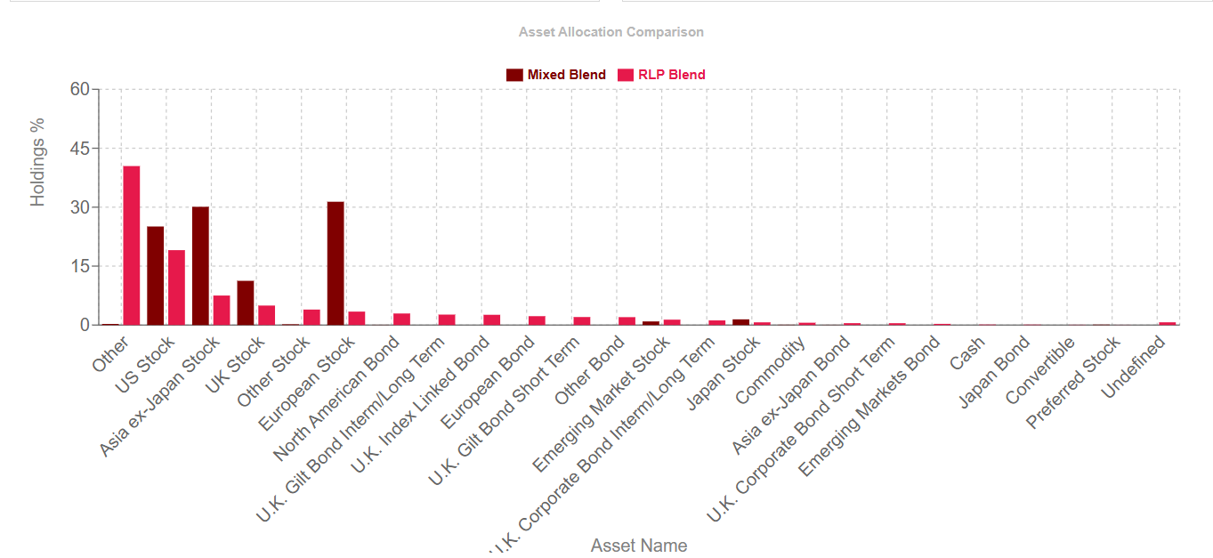

Portfolio Holdings
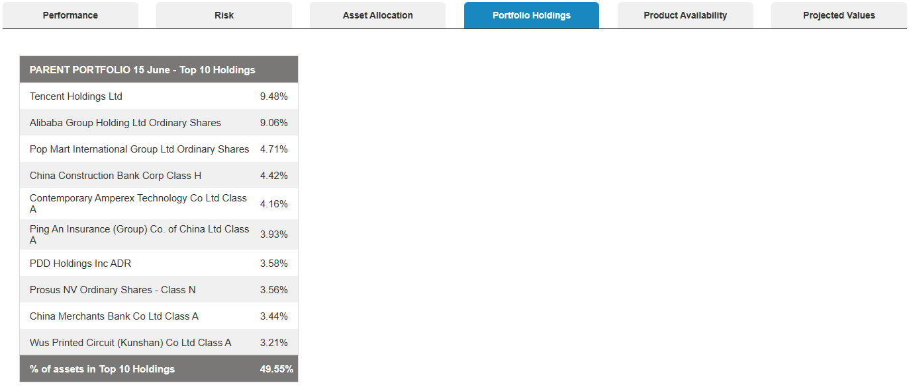
A breakdown of the top ten holdings in each portfolio is displayed on this page. The percentage of the portfolio that is held within these holdings is given below.

Product Availability
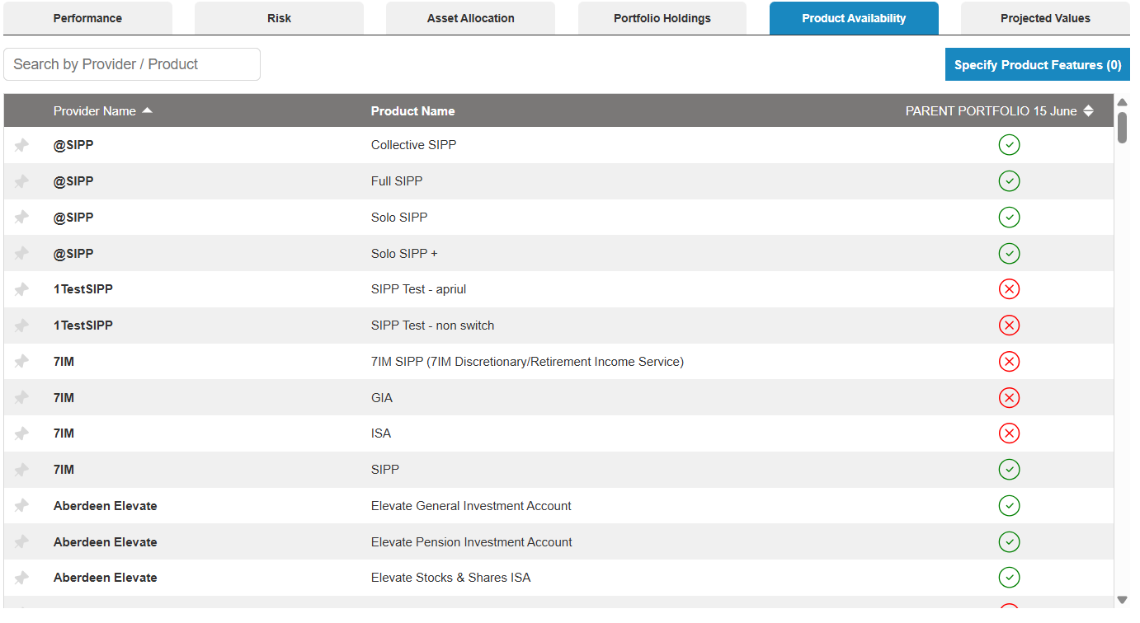
A list of all of the products will be displayed with icons on the right depicting whether the product is available or not. If a product is not available, hovering over the red X icon will show which fund(s) are not available with this product.
Use the field above the list to search for specific providers or refine the list by specifying desirable product features.
Products can be pinned to the top of the list using the icon on the left.

Projected Values
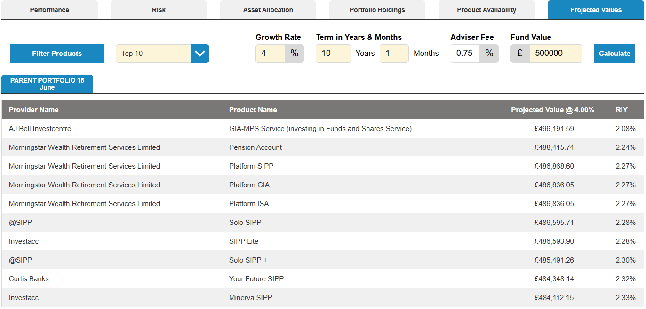
A comparison of the product costs can be created by entering a growth rate, term, adviser fee and fund value. The comparison can be set to include the top 10, top 25, top 50 or all products by choosing from the drop-down list at the top of the page.

Glossary of Filters

Universe and Availability

Fund Universe
MPS, Mutual Fund, Pension Fund, Bespoke Funds

Legal Structure
ETFs, Investment Trusts, OEICs & Unit Trusts, Offshore Funds

Plan Availability
A list of the plans that offer the fund availability

Ratings

Minimum Morningstar Rating
Morningstar ratings from 1 to 5

Sectors
A list of the sectors that the funds are invested in

Costs & Fees

Total Cost
The total ongoing costs of the fund

Costs Excluding Transaction Fees
The ongoing costs of the fund, excluding transaction costs

Asset Content

Equity Content
How much of the fund is held within equities

Fixed Interest Content
How much of the fund is held within fixed interests

Regional Equity Content
Where in the world the funds are invested

Fund Attributes
Environmental Focus, ESG, Fund of Funds, Index Fund, Religious Funds, Sharia Compliant

Performance Metrics

Performance Quartiles
How the fund performed over the defined period, by quartiles

Cumulative Performance
Total performance of the fund

Alpha Ratio
Excess return compared to a benchmark, after adjusting for risk

Beta Ratio
How the investment price moves up and down in comparison with the rest of the market

Sharpe Ratio
A comparison of how much extra return over a safe asset against the total risk or volatility

R²
A statistical measure showing what percentage of a fund's or security's price movements can be explained by movements in a benchmark index

Standard Deviation
How much an asset's returns swing up and down from its average

Fund Characteristics

Min Fund Size
Total amount of money in an investment vehicle

Fund Strategy
Active, Passive, Blended

Fund of Funds
Fund of Funds, Direct Only

Fund Style – Size
Small, Mid, Large

Fund Style – Approach
Value, Blend, Growth

Fund Type
Accumulation, Income, Mixed

